NAME : PAREENITA A.SHIRSATH PRN : 221101062 T.E.A.I.&.D.S. ROLL.NO : 57

**DAV EXPERIMENT 7**

# Load necessary libraries

library(ggplot2)

library(plotly)

data <- read.csv("D:\\Downloads\\Salary_Data.csv")

# Visualization 1: Using ggplot2

ggplot(data, aes(x = YearsExperience, y = Salary)) +

geom_line(color = "blue") +

geom_point(color = "blue") +

labs(title = "Relationship between Years of Experience and Salary (ggplot2)",

x = "Years of Experience",

y = "Salary")

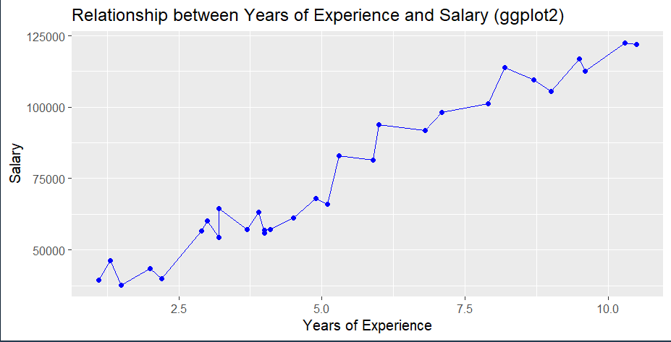

# Visualization 2: Using plotly

plot_ly(data, x = ~YearsExperience, y = ~Salary, type = "scatter", mode = "lines+markers", marker = list(color = "blue")) %>%

layout(title = "Relationship between Years of Experience and Salary (plotly)",

xaxis = list(title = "Years of Experience"),

yaxis = list(title = "Salary"))

